**Analyzing Personal Expenses**

# **Data Simulation :**

## **Utilizing the Faker library to generate a realistic dataset that simulates a person's monthly expenses over the course of a year. The dataset includes essential columns such as transaction_date, category, amount_paid, payment_mode,**

## **description, and cashback**

# **Database Creation :**

## **Establishing a SQL database schema designed to efficiently store and manage the generated dataset of monthly expenses. The schema includes a table named analyzing_personal_expenses, which consists of columns such as**

## **transaction_date, category, amount_paid, payment_mode, description, and cashback. This structure ensures that each expense record is well-defined and easily accessible for querying.**

# **MYSQL Queries:**

## **1 SELECT SUM(Amount_Paid) AS Total_Expenses FROM analyzing_personal_expenses**

## **Result**:**Total Expenses: [(7508925,)]**

## **2. SELECT AVG(Amount_Paid) FROM analyzing_personal_expenses**

## **Result: average :[(1239.0965346534654,)]**

## **3. SELECT MIN(Amount_Paid) AS Total_Expenses FROM analyzing_personal_expenses**

## **Result**: **Minimum Expenses: [('100',)]**

## **4. SELECT MAX(Amount_Paid) AS Total_Expenses FROM analyzing_personal_expenses**

**Result**: **Max Expenses: [('700',)]**

## **5. SELECT * FROM analyzing_personal_expenses LIMIT 5 OFFSET 5**

## **Result**:

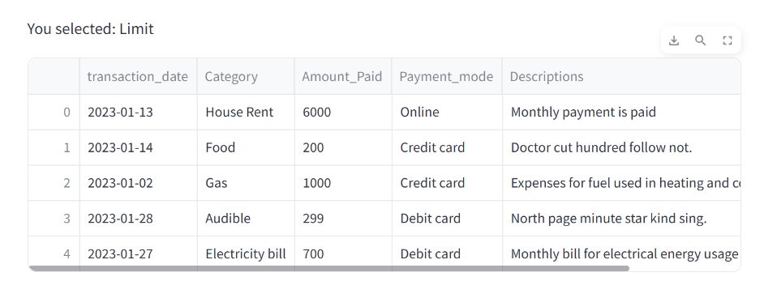

## **6. SELECT MIN(Cashback) FROM analyzing_personal_expenses**

**Result**: **Minimum Cashback: [('0.0',)]**

## **7. SELECT MAX(Cashback) FROM analyzing_personal_expenses**

## **Result**: **Maximum Cashback: [('90.71',)]**

## **8. SELECT AVG(Cashback) FROM analyzing_personal_expenses**

## **Result**: **average cash :[(18.98759900990099,)]**

## **9. SELECT sum(Cashback) AS Total_CashBack FROM analyzing_personal_expenses**

## **Result**: **Total Cashback: [(299168.61,)]**

## **10. SELECT count(Cashback),Amount_Paid FROM analyzing_personal_expenses group**

**by Amount_Paid order by count(Cashback)**

## **Result**:

## 

## **11. SELECT * FROM analyzing_personal_expenses WHERE Category = 'Food' AND**

## **Payment_mode = 'Cash'**

## **Result**:

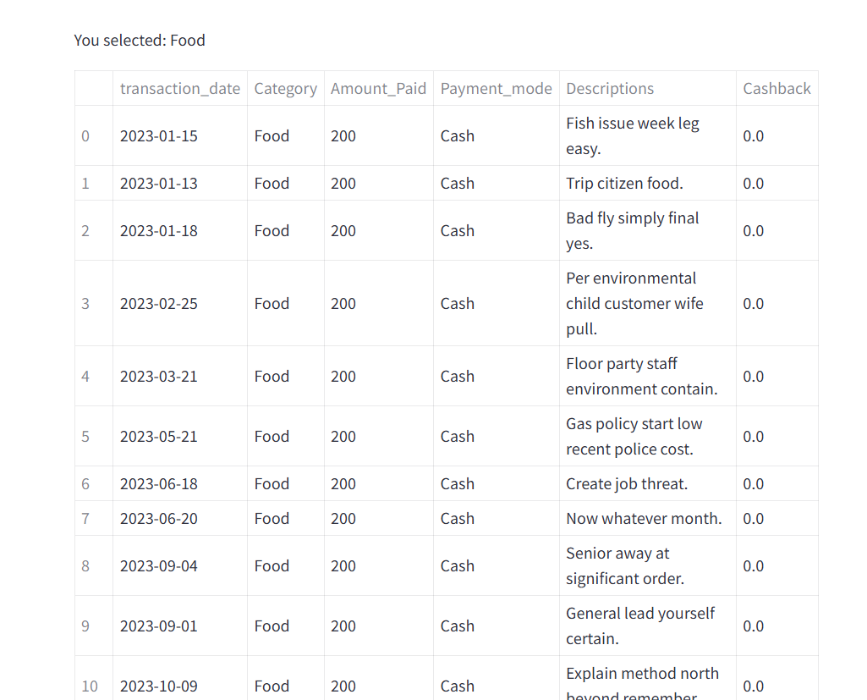

## **12. SELECT * FROM analyzing_personal_expenses WHERE Category = 'Shopping' AND**

## **Payment_mode = 'Debit card'**

## **Result**:

## 

## **13. SELECT * FROM analyzing_personal_expenses WHERE Payment_mode = 'Credit**

**card'**

## **Result**:

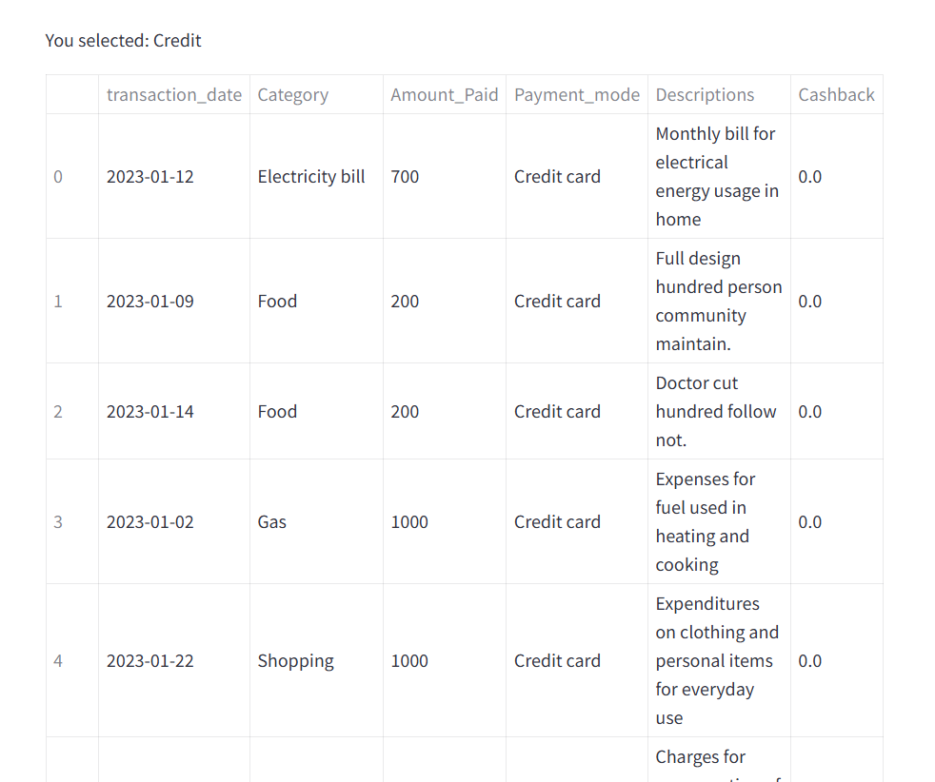

## **14. SELECT * FROM analyzing_personal_expenses WHERE Payment_mode = 'Online'**

## **Result**:

## 

## **15. select transaction_date,sum(Amount_Paid) AS TotalAmount,sum(Cashback) AS Totalcashbacks from analyzing_personal_expenses group by transaction_date**

## **Result**:

## 

# **Data visualization:**

## **Pie chart for Payment mode there are 4 category for payment**

## 

## **Bar chart for Number of Transactions for Food Category by Payment Mode**

## 

## **Donut chart for Categorys:**

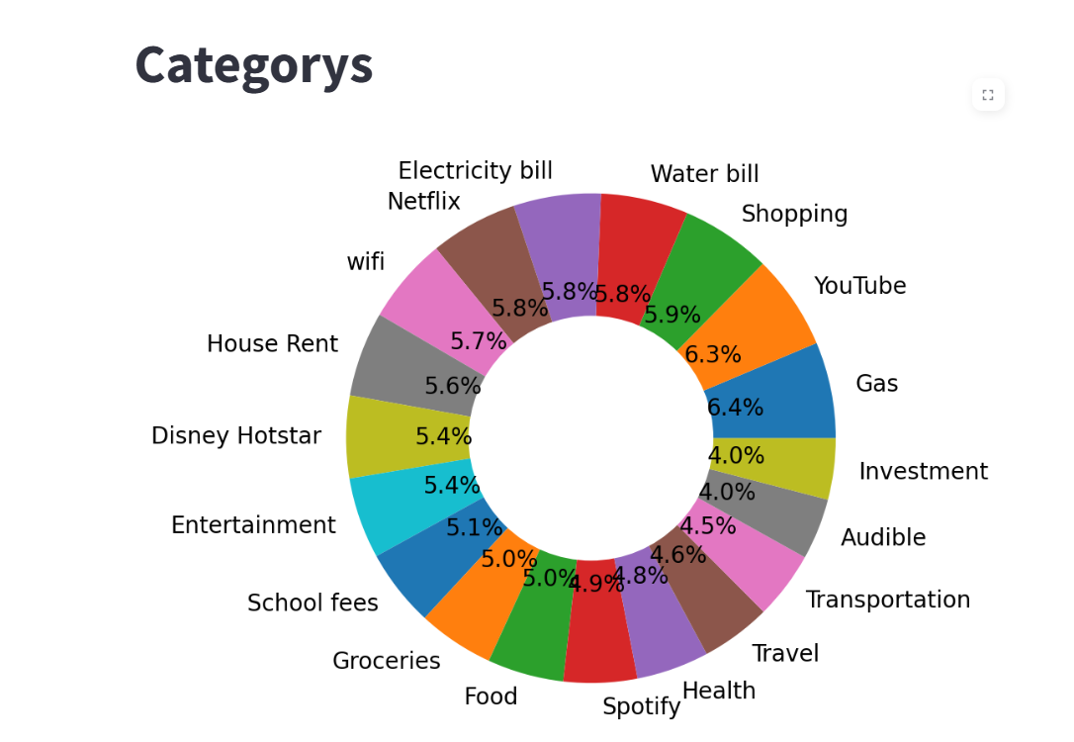

## **Number of Transactions by Category and Payment Mode**

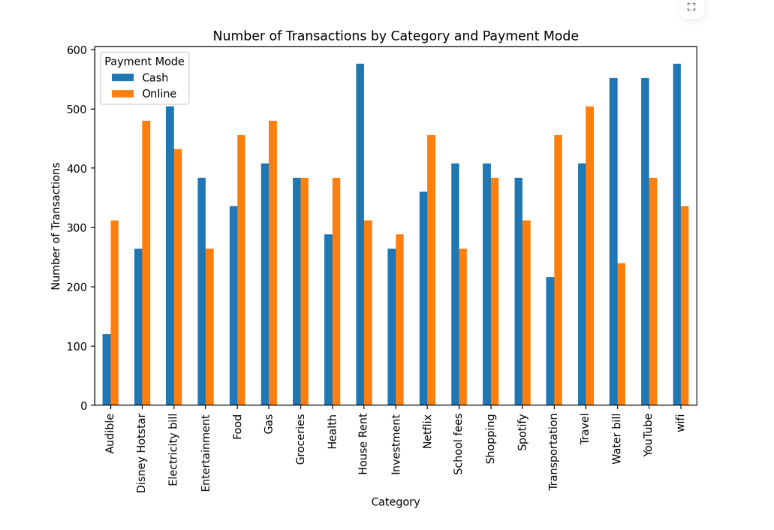

## **Histogram of Amount Paid**

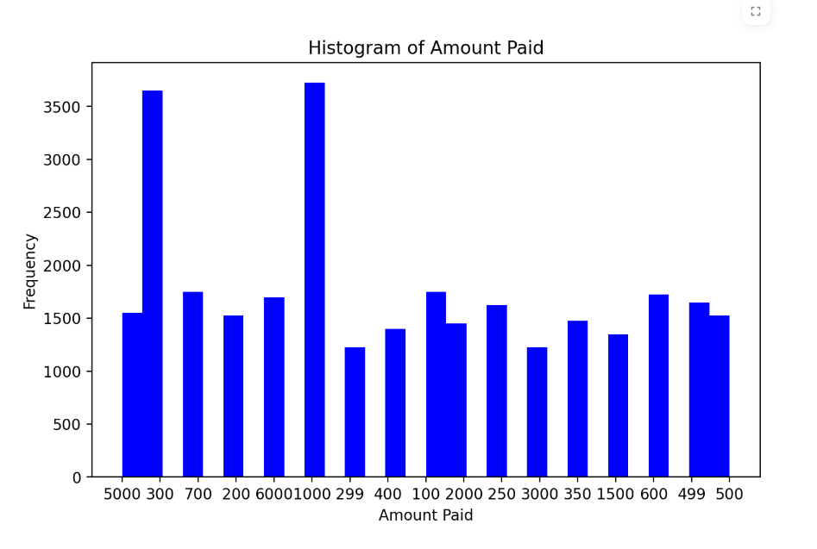

## **The below bar chart show the which month has highest expenses**

## 